# Cute Http File Server jwt

# Get Cookies for Admin

This project has no registration function, so we need to set up a local environment, register an admin user



then locally login

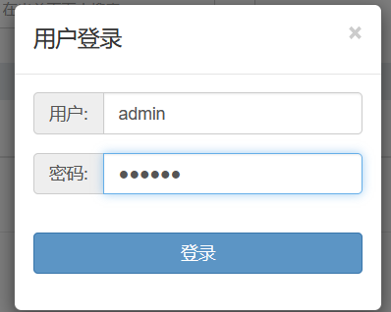

**and obtain their cookies after login successfully**

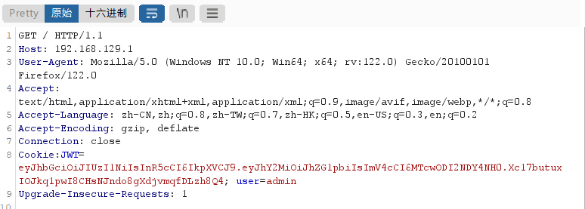

# JWT Decryption and Forgery

JJWT decryption, the payload only contains the admin user we just registered, without verifying the current user's password. At the same time, the symmetric key has also been decrypted. From then on, any identity login can be achieved using JWT

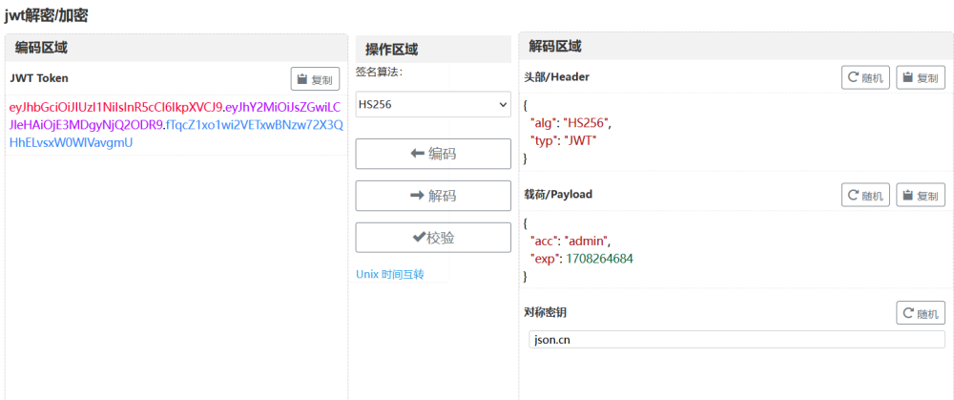

# Experimental effect

## before login

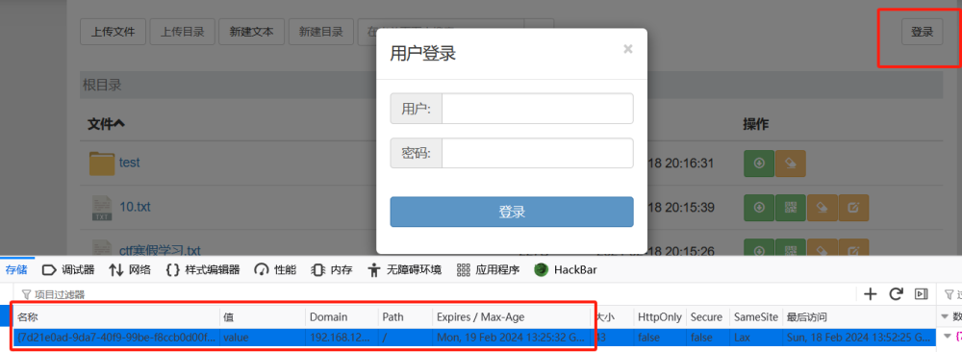

## successful jwt forgery

